Come fly with me!

*Book your own trip to the United Kingdom!*



Travel Agency name: Olav Hoogstraten, Wout Grootemarsink

Group Members:

1. Olav Hoogstraten Class: T3A
2. Wout Grootemarsink Class: T3A

The assignment

Dag allemaal,

De bedoeling van het project is, dat jullie in alleen of met z’n tweeën, een reis gaan uitstippelen voor twee personen. De reis gaan jullie uitzoeken op Engelse websites van de aangegeven vliegtuigmaatschappijen, hotels met Engels ontbijt en je zoekt 6 activiteiten voor de reis. Zorg dat de tijd van de vlucht en de datum op elkaar aansluiten, dus dat beide aankomstdagen hetzelfde zijn. Jullie krijgen hiervoor een bepaald bedrag waar je **niet** overheen mag! De duur van de reis is een mid-week, dus 5 dagen.

Jullie geven voorbeelden en bewijs van de opgezochte informatie via print screen. Deze print screen plakken jullie achter de juiste opdracht (vluchten bij opdracht vliegtuigmaatschappijen ect.) Je begint met het invullen van het samenwerkingscontract en het verdelen van de taken bij het kopje takenverdeling. Van daar uit werk je het boekje door. Als je alleen werkt, schrijf je een plan van aanpak wanneer je wat gaat doen.

Uiteindelijk lever je het boekje in bij de docent en presenteer je de reis voor de klas met een PowerPoint.

**Hoe is dit project verdeeld?**

*Les 1: Korte introductie van je docent over de opdracht. Vervolgens ga je met jullie*

*groep aan de slag met het projectboekje. Je gaat beginnen met een*

*plan van aanpak maken, de taken verdelen en een start met de opdrachten.*

*Les 2: Opzoeken van informatie/verder werken aan de opdrachten.*

*Les 3: In deze les gaan jullie de presentatie in elkaar zetten, je maakt gebruik van een*

*PowerPoint of Prezi.*

*Hierna volgen de PRESENTATIES!*

*De presentatie is minimaal 3 minuten, maximaal 6. Als je met twee personen bent, verdeel je de presentatie evenredig.*

*In je presentatie staan (minimaal) de vluchten, het hotel en de activiteiten.*

*Aan het einde van de les vullen jullie de evaluatie in.*

|  |
| --- |
| **INFORMATIE MET BETREKKING TOT DE REIS**  **De reis wordt geboekt op een maandag en de terugvlucht op vrijdag:**   * 17 oktober t/m 21 oktober 2016 * 24 oktober t/m 28 oktober 2016   **Het bedrag dat jullie krijgen om uit te geven is:**   * **€ 2000,-**   **Aantal dagen:**   * Mid-week, dus 5 dagen * 4 overnachtingen |

Samenwerkingscontract groep

**Namen + Mail adressen:**

Olav Hoogstraten – [olavhoogstraten@gmail.com](mailto:olavhoogstraten@gmail.com)

Wout Grootemarsink – [Woutgrootemarsink@gmail.com](mailto:Woutgrootemarsink@gmail.com)

**Groepsregels:**

***Wat doen jullie bij afwezigheid of ziekte van jullie groepsgenoot of jezelf?***

Zorgen jij je werk af hebt en de ander die ziek is helpen.

***Wat doe je bij onenigheid/ruzie in jullie groepje?***

Een tussen oplossing zoeken

***Hoe gaan jullie het werk verdelen? (+tijdsplanning)***

We proberen zo veel mogelijk in les samen te doen en de rest verdelen we wat we graag zelf willen doen.

***Hoe blijf je van elkaars werk op de hoogte?***

Zo veel mogelijk samen doen.

***Wat doen jullie als je iets niet snapt?***

Dan vragen we het aan andere of aan de docent. Plan van Aanpak Individueel

**Naam + E-mailadres:**

---------------------------------------------------------------------------------------------------------------------------------------------------------------------------------------------------------------------------------------------------------------------------------------------------------------------------------------------------------------------------------------------------------------------------------------------------------------------

**Afspraken richting docent:**

***Wat doe je bij afwezigheid of ziekte?***

---------------------------------------------------------------------------------------------------------------------------------------------------------------------------------------------------------------------------------------------------------------------------------------------------------------------------------------------------------------------------------------------------------------------------------------------------------------------

***Hoe gaan je het werk verdelen? (+tijdsplanning)***

---------------------------------------------------------------------------------------------------------------------------------------------------------------------------------------------------------------------------------------------------------------------------------------------------------------------------------------------------------------------------------------------------------------------------------------------------------------------

---------------------------------------------------------------------------------------------------------------------------------------------------------------------------------------------------------------------------------------------------------------------------------------------------------------------------------------------------------------------------------------------------------------------------------------------------------------------

***Wat doe je als je iets niet snapt?***

---------------------------------------------------------------------------------------------------------------------------------------------------------------------------------------------------------------------------------------------------------------------------------------------------------------------------------------------------------------------------------------------------------------------------------------------------------------------

Taakverdeling

|  |  |  |  |  |
| --- | --- | --- | --- | --- |
| **Taak.** | **Wie?**  (nvt bij individueel) | **Wanneer af?** | **Benodigdheden?** | **Gedaan?** |
|  |  |  |  |  |
|  |  |  |  |  |
|  |  |  |  |  |
|  |  |  |  |  |
|  |  |  |  |  |
|  |  |  |  |  |
|  |  |  |  |  |
|  |  |  |  |  |
|  |  |  |  |  |
|  |  |  |  |  |
|  |  |  |  |  |
|  |  |  |  |  |
|  |  |  |  |  |
|  |  |  |  |  |

A trip to Great Britain!



Opdracht 1: Vluchten bekijken, uitkiezen

Opdracht 2: Hotels bekijken, uitkiezen

Opdracht 3: Uitzoeken, kiezen en beschrijven activiteiten

Opdracht 4: Presentatie! PowerPoint maken/rolverdeling presenteren

3 minuten minimaal, maximaal 6.

+ Persoonlijke evaluatie

Assignment 1: Choose your destination and book your flight

**Opdracht: Come fly with me**A TRIP TO THE UK

You will be acting as a travel agent. Either by yourself or together you will be planning a trip to Great Britain. The obvious place would be London. However, I also dare you to look beyond London.

With every assignment you complete, you will notify your teacher. This means that after ‘Opdracht 1’ you will reflect back to me that you completed it and whether you have any questions or not. After ‘Opdracht 2’ the same, and so on.

You all bare responsibility for the tasks ahead. This means, that if you are working together with someone who is not pulling their weight, you have to inform me in a timely manner. If I figure out you have not done what you are supposed to do on hindsight, I will not be able to support you.

And for now…. Good luck!

Follow below steps:

**Step 1:**

Go to the website below:

<http://www.easyjet.com/en/>

**Step 2:**

Find your flights (example)

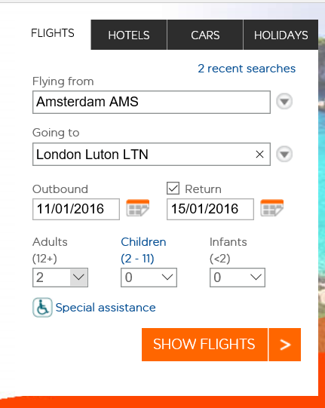

**You will find out what a return flight will cost to your chosen destination in the UK.**

* **You will fly from Amsterdam (AMS) to >your destination in the UK<**
* **Double check you have the correct dates**
* **The ticket is for two adults**
* **You have to book your flight from the Monday morning to the Friday afternoon**
* **Choose your best option**
* **Don’t forget to print screen!**

**Stap 3:**

**Ensure you write down all the details of the flight including showing your printscreen. Think about times, dates, prices, luggage and any additional things you might want to add.**

|  |
| --- |
| Details flights: we will fly at the 24th of October to Cardiff form Schiphol Amsterdam, with KLM airlines. The plane tickets will kost 98 pounds. On Friday 28th of October we will fly back to Holland. Also with KLM. The flight will take one and a half hour. |

Assigment 1: Print Screen Flights

Please paste your print screen of your flight information below

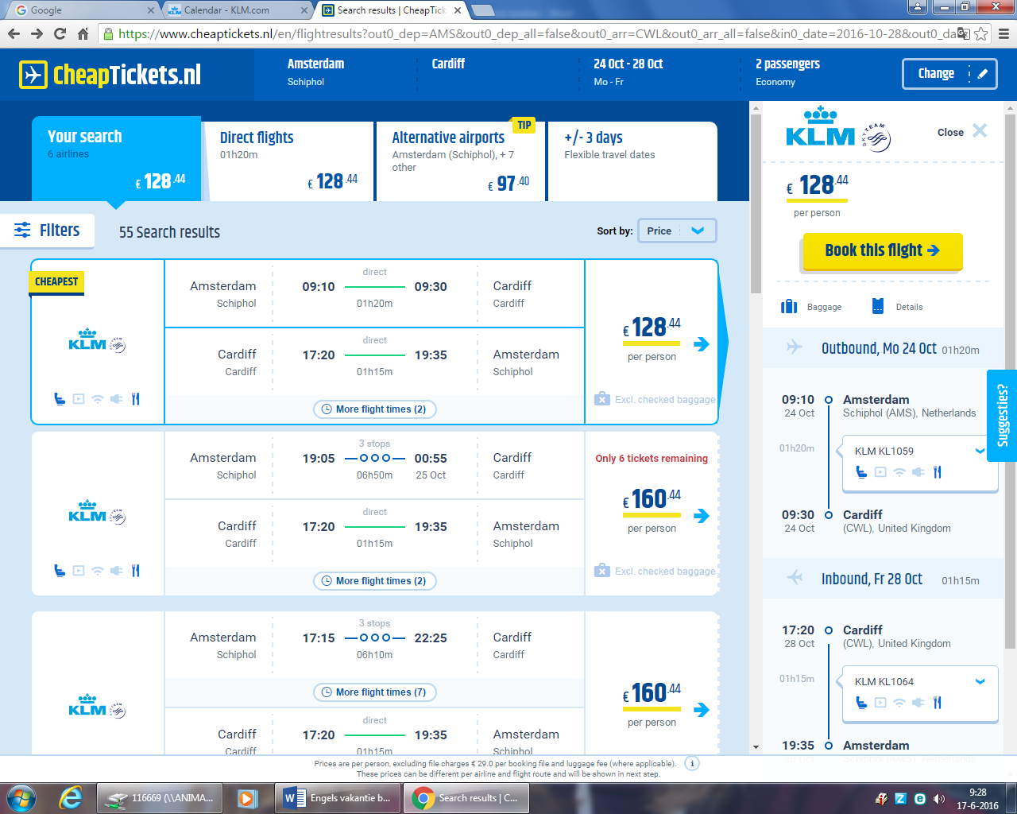Assignment 2: Book your stay

**Step 4:**

**In your previous assignment, you have chosen your flights to your destination. On top of going there, you will need a place to stay.**

**The minimum requirements are:**

* **It has to be one accommodation for the 4 nights you are there**
* **You need to include breakfast**
* **It has to be within your budget**
* **It has to have come from an English website**

**Tips for accommodation websites:**

* [**http://www.bedandbreakfasts-uk.co.uk/**](http://www.bedandbreakfasts-uk.co.uk/)
* [**http://www.bedandbreakfastnationwide.com/**](http://www.bedandbreakfastnationwide.com/)
* [**http://www.hotels.uk.com/**](http://www.hotels.uk.com/)
* **If you were to find another English website, that is allowed. Make sure you state your source!**

**Stap 5:**

* Write down the details of your accommodation, including dates, prices and facilities

|  |
| --- |
| Accommodation details:  We will book our accommodation in the center of Cardiff in the Clayton hotel. There is breakfast in the morning and you can wat at the hotel in the afternoon. From the 24th till the 27th we will stay at the Clayton hotel. ………………………………………………………………………………………………..  ………………………………………………………………………………………………..  ………………………………………………………………………………………………..  ………………………………………………………………………………………………..  ………………………………………………………………………………………………..  ………………………………………………………………………………………………..  ………………………………………………………………………………………………..  ………………………………………………………………………………………………..  ………………………………………………………………………………………………..  ………………………………………………………………………………………………..  ………………………………………………………………………………………………..  ………………………………………………………………………………………………..  ………………………………………………………………………………………………..  ………………………………………………………………………………………………..  ……………………………………………………………………………………………….. |

Assignment 2: Accommodation

Please paste your print screen of your accommodation information below

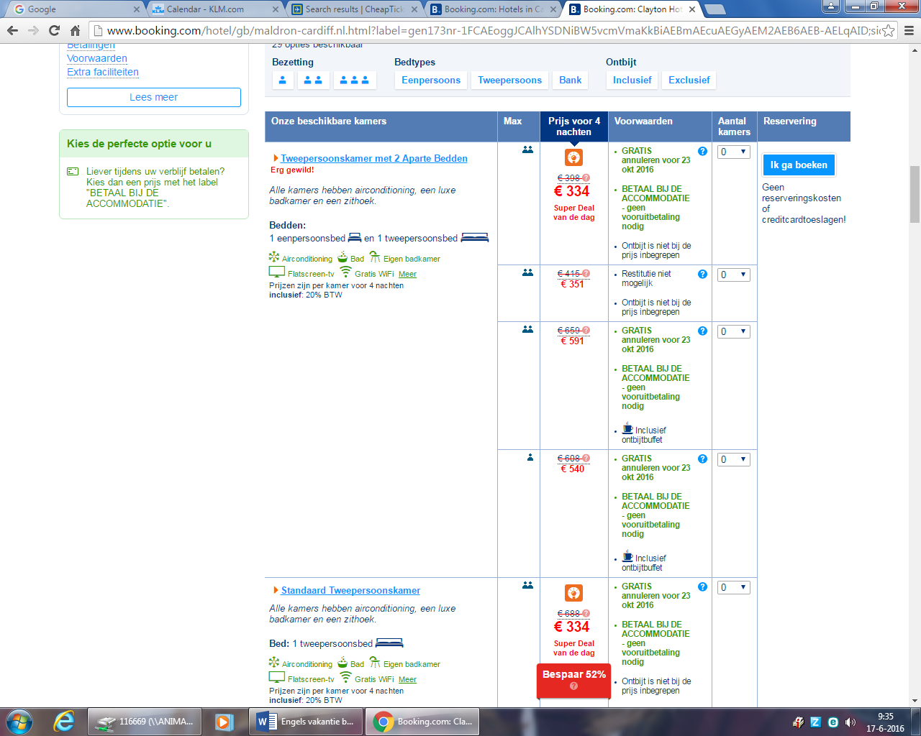

Assignment 3: What to do?

**Stap 6:**

You have booked your stay! Congratulations! However, you are a busy bee and would like to do something when you are there. After your arrival you will have to find a few activities. Please read below.

* **Day 1 (Monday):** your day of arrival. You will have a walk around your accommodation

and you will have to find a restaurant to eat at.

* **Day 2 (Tuesday):** visit to 1 activity
* **Day 3 (Wednesday):** visit to 1 activity
* **Day 4 (Thursday):** visit to 1 activity
* **Day 5 (Friday):** today is the end of your short break. See if you have any money and time left to do something.

**Please note!**

You are not allowed to visit the same activity twice!

**Activities could include:**

* Musea
* Events
* Gigs
* Theatre
* Anything the local ‘tourist office’ has to offer
* Any activity you would like to do whilst on holiday

**Be creative!**

|  |  |
| --- | --- |
| Day 1 | **Activity**: chilling and seeing the city.  **Place:** Cardiff, Hotel  **Description**: The first day we will unpack our backs and chil out at our hotel room. Later this day we go in to the city and see what this place will bring us the upcoming days. |
| Day 2 | **Activity**: : mountainbiken in South Wales.  **Place**: ,Merthyr Tydfil  **Description**: the next day we will get more sportive. We go to Merthyr Tydil with our car and hire two mountain bikes for the whole day. We will be cycling on a park with the coolest jumps and stunts. This outgoing wil cost 140 pounds, this is for the bikes, access to the park and for our foods and drinks. In the evening we will getting out for a dinner in the city |
| Day 3 | **Activity**: Welsh Hawking  **Place**: South Glamorgan  **Description**: Wednesday is a chill day with a lot of birds. Birds? I hear you think, but yes birds. We will go to Welsh Hawking center. This is a canter were you can walk with a major eagle on your arm. Or a small raptor. This day will cost us 32 pounds for the entrance plus food and drinks. |
| Day 4 | **Activity**: hiking  **Place**: Cardiff wales  **Description**: Thursday we still be sportive with hiking in the most beautiful places in the world. We will make a walk of 10+ km with ups and downs. Slow and fast, wet and dry landscapes. This trip will cost us 15 pounds for only the food and drinks we will bring with us because this hiking place is a free place to walk. You only have to follow the posts. |
| Day 5 (optional) | Activity:……………………………………………….  Place: ………………………………………………..  Description:  ………………………………………………………..  ………………………………………………………..  ………………………………………………………..  ………………………………………………………..  ………………………………………………………..  ……………………………………………………….. |

Assigment 3: Activities

Please paste your print screens of your activities information below

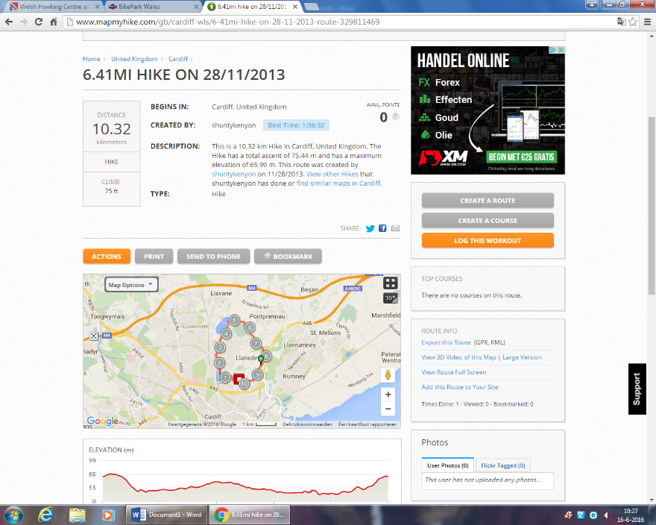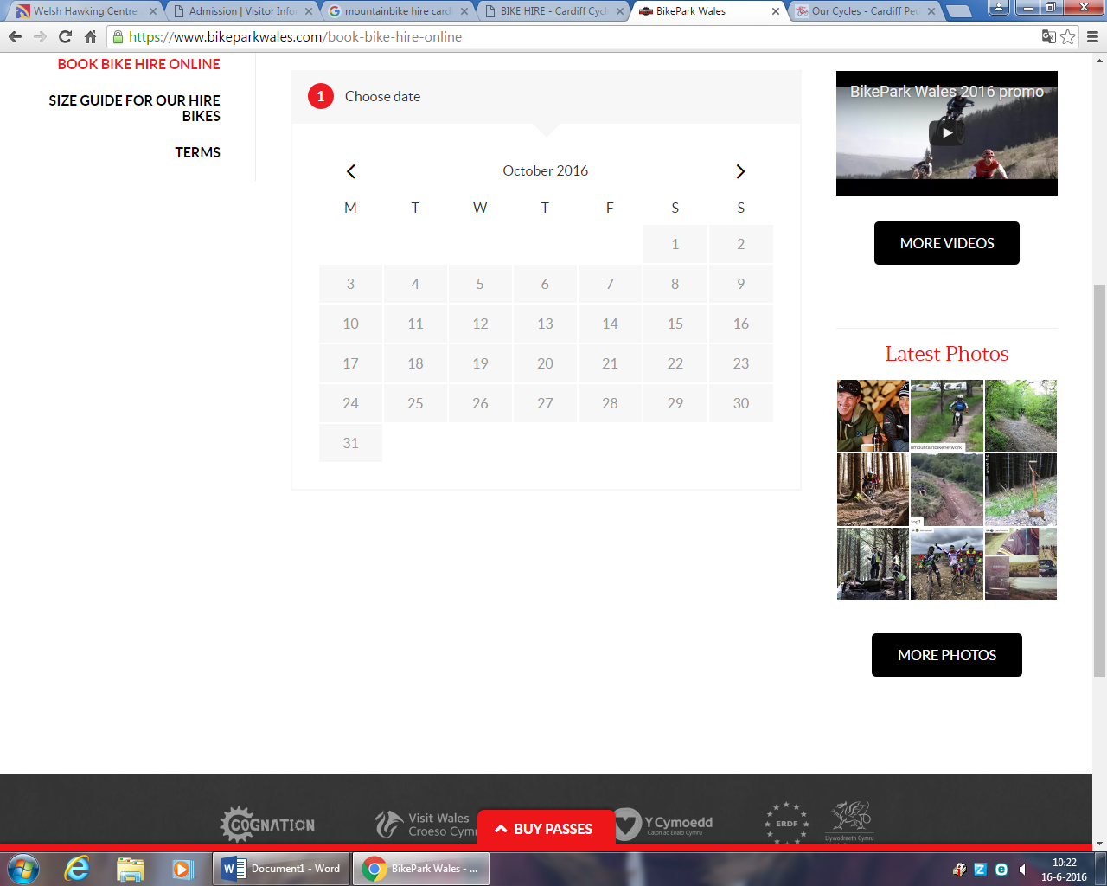

Assigment 4: Presentation

**Step 7:**

All of your information will now be gathered in a PowerPoint Presentation. Ensure it is a detailed description of your stay in the UK. And yes, it has to be in English.

Any questions, you know where to find me or email me via ELO/Magister.

Assignment 5: Personal Evaluation (pupil 1)

**Name**: Wout Grootemarsink

**Teacher**: S.H. Klomp

**Date**: 5 July 2016

**The tasks I contributed were:**

We have done everything together.

**This is my opinion about the task and end result. Please explain.**

I think we done it well. We had a good teamwork and had a lot of fun to make it and sort out were we will go to ,which activities we should choose and were we will spent money on.

**If you worked independent, please tell me what you found easy/hard/or what stood out for you.**

**If you worked together, please explain what you found easy/hard/or what stood out for you.**

To tell what we going to do at all days was a realy hard thing for us. All different details and stories to

make was a hard job.

**Give yourself a grade on a scale from 1 to 10 about the full project.**

**Naam:** Wout Grootemarsink 1 2 3 4 5 6***7*** 8 9 10

**What did you think about the project and what could improve it?**

I think this was a great project on a perfect moment. At holyday almost everyone wil go on a trip and to make one before holyday starts is the perfect moment to make it. maybe it was more fun that we could go were we wanted, and not only places of the United Kingdom. But to make it: A trip on the world!

**Please grade the project assignments:**

A trip to the UK! 1 2 3 4 5 6 7 ***8*** 9 10

Assignment 5: Personal Evaluation (pupil 2)

Name: Olav Hoogstraten

Teacher: S.H. Klomp

Date: 5 Juli 2016

The tasks I contributed were:

We did most of the things together.

This is my opinion about the task and end result. Please explain.

I think we did it really good because we were able to find what we needed and we did it fast so we had a lot of time left to make it better. Also our teamwork was really good so that helps a lot.

If you worked independent, please tell me what you found easy/hard/or what stood out for you.

If you worked together, please explain what you found easy/hard/or what stood out for you.

It was really hard to make perfect appointments, because some times one of us was faster ready than we thought he was going to. So that was the hard thing about it.

Give yourself a grade on a scale from 1 to 10 about the full project.

Naam: Olav Hoogstraten 1 2 3 4 5 6 *7* 8 9 10

What did you think about the project and what could improve it?

I think it was a really nice idea to make this project because children like us can see how it is to plan a little vacation, so they know how it needs to be done for maybe a next time.

Please grade the project assignments:

A trip to the UK! 1 2 3 4 5 6 7 8 *9* 10